### A

B.TECH. PROJECT REPORT ON

**VEHICLE EMISSION MONITORING AND CONTROL USING IOT**

*Submitted in partial fulfillment of the requirements for the award of the degree of*

Bachelor of Technology in

Information Technology by

Harshit Arun Gujarathi (T2154491246505)

Lokesh Dipak Patil (T2054491246026)

Manish Shankarlal Makhija (T2054491246030)

Ramandeepkaur Narendrapal Banvat (T2054491246044)

### Under the guidance of

### **Dr. Bhushan Chaudhari**



## DEPARTMENT OF INFORMATION TECHNOLOGY

SHRI VILE PARLE KELAVANI MANDAL’S

# INSTITUTE OF TECHNOLOGY, DHULE

Survey No. 499, Plot No. 02, Behind Gurudwara, Mumbai-Agra National Highway, Dhule-424001, Maharashtra, India.

## Academic Year 2023 – 24

SHRI VILE PARLE KELAVANI MANDAL’S

# INSTITUTE OF TECHNOLOGY, DHULE

Survey No. 499, Plot No. 02, Behind Gurudwara, Mumbai-Agra National Highway, Dhule-424001, Maharashtra, India.

## Academic Year 2023 – 24



***CERTIFICATE***

This is to certify that the B.TECH. Project Report Entitled

**VEHICLE EMISSION MONITORING AND CONTROL USING IOT**

Submitted by

Harshit Arun Gujarathi (T2154491246505)

Lokesh Dipak Patil (T2054491246026)

Manish Shankarlal Makhija (T2054491246030)

Ramandeepkaur Narendrapal Banvat (T2054491246044)

is a record of bonafide work carried out by him/her, under our guidance, in partial fulfillment of the requirement for the award of Degree of Bachelors of Technology (Information Technology) at Shri Vile Parle Kelawani Mandal's Institute Of Technology, Dhule under the Dr. Babasaheb Ambedkar Technological University, Lonere, Maharashtra. This work is done during semester VIII of Academic year 2023-24.

Date:

Place: SVKM’s IOT, Dhule

|  |  |  |
| --- | --- | --- |
| Prof. Rubi Mandal | Dr. Bhushan Chaudhari | Dr. Nilesh Salunke |
| **Project Coordinator** | **Project Guide &HOD** | **Principal** |

Name and Sign with date Name and Sign with date Examiner-1 Examiner-2

## DECLARATION

We declare that this written submission represents my ideas in our own words and where other’s ideas or words have been included, we have adequately cited and referenced the original sources. We also declare that we have adhered to all principles of academic honesty and integrity and have not misrepresented or fabricated or falsified any idea/data/fact/source in our submission. We understand that any violation of the above will cause for disciplinary action by the Institute and can also evoke penal action from the sources which have thus not been properly cited or from whom proper permission has not been taken when needed.

Signatures

|  |  |  |
| --- | --- | --- |
| Harshit Arun Gujarathi | (T2154491246505) |  |
| Lokesh Dipak Patil | (T2054491246026) |  |
| Manish Shankarlal Makhija | (T2054491246030) |  |
| Ramandeepkaur Narendrapal Banvat | (T2054491246044) |  |

## ACKNOWLEDGEMENTS

We have immense pleasure in expressing our interest and deepest sense of gratitude towards our project guide Dr. Bhushan Chaudhari for the assistance, valuable guidance and co-operation in carrying out this project successfully. It is a privilege for us to have been associated with Dr. Bhushan Chaudhari, our Project Guide, during our Project Phase 2 work. We have greatly benefited from his valuable suggestion and ideas. It is with great pleasure that we express our deep sense of gratitude to him for his valuable guidance, constant encouragement and patience throughout this work. We express our gratitude and are thankful to all people who have contributed in their way in making this final year project phase 2 success. Particularly we want to thank Prof. PQR, Project Coordinator for our department for making this process seamless for us and arranging everything so perfectly. I take this opportunity to thank all the classmates for their company during the course work and for the useful discussion, I had with them. We take this opportunity to express our heartfelt gratitude towards the Department of Information Technology of Shri Vile Parle Kelavani Mandal’s Institute of Technology, Dhule and Dr. Nilesh Salunke, Principal of Shri Vile Parle Kelavani Mandal’s Institute of Technology, Dhule, that gave us an opportunity for the presentation of our project phase 2 in the esteemed organization and for providing the required facilities in completing this project. We are greatly thankful to our parents, friends and other faculty members for their motivation, guidance and help whenever needed.

## INDEX

|  |  |  |
| --- | --- | --- |
| **SR.**  **NO.** | **TITLE** | **PAGE NO.** |
|  | List of Abbreviations | I |
|  | List of Figures | II |
|  | List of tables | III |
|  | Abstract | IV |
| 1 | Introduction | 1 |
| 2 | Literature Survey | 5 |
| 2.1 | Survey Existing system | 5 |
| 2.2 | Limitation Existing system or research gap | 7 |
| 3 | Problem Statement | 9 |
| 3.1 | Project Requirement Specification | 9 |
| 4 | Proposed System | 14 |
| 4.1 | Proposed System Architecture | 14 |
| 4.2 | Proposed Methodology | 15 |
| 5 | Details of Hardware &Software requirements | 18 |
| 6 | System Design details | 20 |
| 7 | Feasibility Study | 26 |
| 8 | Experimentation and Results | 32 |
| 8.1 | Details of Database/Dataset (if any) | 32 |
| 8.2 | Block by block results of complete experimentation | 34 |

|  |  |  |
| --- | --- | --- |
| 8.3 | Discussion | 37 |
| 9 | Conclusion | 39 |
| 10 | References (must be as per the IEEE citation rules) | 41 |
|  | o Datasheets of all components used in the design |  |
|  | o Formulae / Mathematical support used in algorithm development |  |
|  | o Quality Assessment Measures (used for testing outputs) |  |
| 11 | Copyrights/Patents/Paper and/or Certificate Presented/Published in Conference/Journal |  |
|  | Appendix A: Copyrights/ Patents of your Project work |  |
|  | Appendix B: Certificates of Published Paper |  |
|  | Appendix C: Actual print of Published Paper |  |

**LIST OF ABBREVIATIONS**

|  |  |
| --- | --- |
| **EN** | **Entropy** |
| IoT | Internet of Things |
| PUC | Pollution Under Control |
| CO | Carbon Monoxide |
| CO2 | Carbon Dioxide |
| HC | Hydrocarbon |
| GPIO | General Purpose Input / Output |
| PPM | Parts per Million |
| CAN | Controller Area Network |

**LIST OF FIGURES**

|  |  |  |
| --- | --- | --- |
| **Fig No.** | **Name of Figure** | **Page No** |
| 3.1.1 | ESP 32 Dev Board with USB micro-B cable | 9 |
| 3.1.2 | MQ135 | 10 |
| 3.1.3 | MQ2 | 11 |
| 3.1.4 | MQ7 | 12 |
| 3.1.5 | Breadboard and Jumper wires | 13 |
| 4.1 | System Architecture | 14 |
| 6.1 | Use case Diagram | 20 |
| 6.2 | Object Diagram | 21 |
| 6.3 | Sequence Diagram | 23 |
| 6.4 | State Diagram | 24 |
| 8.1 | Data Visualization of MQ sensor data | 33 |
| 8.2.1 | Analog/raw values from MQ sensor | 34 |
| 8.2.2 | Data Visualization from ThingSpeak Cloud | 35 |
| 8.2.3 | Mobile application to read Data | 36 |
| 8.2.4 | User’s review on project | 37 |

#### LIST OF TABLES

|  |  |  |
| --- | --- | --- |
| **T. NO.** | **NAME OF TABLE** | **PAGE NO.** |
| 4.2 | MQ Sensor Details | 7 |
| 8.1 | Sensor’s Calibrated values dataset | 32 |

## Abstract

Vehicle emissions monitoring and control using the Internet of Things (IoT) is a promising approach to reduce air pollution and improve public health. IoT-based vehicle emissions monitoring systems can collect real- data on the levels of pollutants emitted by vehicles, such as carbon monoxide (CO), nitrogen oxides (NOx), and particulate matter (PM). This data can be used to identify vehicles with high emissions, to notify vehicle owners of potential problems, and to enforce emissions standards. IoT-based vehicle emissions control systems can go even further, using the collected data to automatically adjust vehicle settings or even to take vehicles out of service if their emissions exceed certain levels. This can help to ensure that all vehicles are operating as cleanly as possible. The sensor data is then transmitted to a microcontroller, which analyzes the data and takes appropriate action. IoT-based vehicle emissions monitoring and control systems have several potential benefits. They can result in reducing air pollution and improve public health, increase fuel efficiency and save drivers money, Extend the life of vehicles and reducing greenhouse gas emissions and mitigate climate change.

As the technology continues to develop and become more affordable, IoT-based vehicle emissions monitoring and control systems are expected to become more widely deployed. Here are some specific examples of how IoT-based vehicle emissions monitoring and control systems can be used: In identifying vehicles with high emissions: IoT-based systems can be used to identify vehicles that are emitting high levels of pollutants. This information can be used to notify vehicle owners of potential problems, such as a faulty catalytic converter, or to enforce emissions standards. Reducing vehicle idling: Idling vehicles are a major source of air pollution. IoT-based systems can be used to detect idling vehicles and to send alerts to drivers or to take other measures to reduce idling and promote preventive maintenance: IoT-based systems can be used to monitor vehicle emissions over time. This information can be used to identify vehicles due for maintenance or that have developing problems. This can help to prevent vehicles from breaking down and emitting excessive pollutants.

## Introduction

Since vehicle emissions are one of the main causes of air pollution and can have a serious impact on both the environment and human health, it is imperative that we effectively monitor and regulate them. By using the Internet to establish real-time connections between components and the Internet, the Internet of Things makes it possible to design emissions monitoring and control systems more effectively and efficiently than they can be done now.

We must efficiently monitor and control vehicle emissions to reduce these emissions, which are one of the most significant sources of air pollution and can have major consequences on human health and the environment. The Internet of Things uses the Internet to create real-time connections between components and the Internet, enabling emissions monitoring and control systems to be developed in a more efficient and effective approach than is currently available. The ESP32 development microcontroller, with its Wi-Fi and Bluetooth modules, is a flexible and powerful microcontroller that can be used to design IOT devices. It is equipped with a Wi-Fi and Bluetooth module, enabling it to connect to the internet and other devices. In India, the Pollution Under Control (PUC) system is a mandated vehicle emission testing initiative aimed at lowering vehicle-related air pollution. Since its initial introduction in Delhi in 1991, the program has been carried out in all the nation's main cities.

All cars must submit to periodic emissions testing at PUC centers authorized under the PUC system. The vehicle's emissions of different pollutants, including nitrogen oxides, hydrocarbons, and carbon monoxide, are measured during the tests. India's air pollution has decreased thanks in large part to the PUC system. But the system's shortcomings and lack of openness have also drawn criticism. The prevalence of phony PUC certificates is one of the main obstacles. By paying PUC center employees, or by having their cars evaluated without being examined, many car owners can get PUC certificates. This compromises the system's efficacy and permits the continued use of cars that cause pollution on the highways. A further difficulty is the absence of national standards. Every state has its own emission standards and PUC testing protocols. Car owners may find it challenging to adhere to the PUC system as a result, particularly if they travel between states frequently. The PUC system is nevertheless a valuable instrument for lowering air pollution in India despite these difficulties.

The government has implemented several initiatives to increase the system's efficacy, including the creation of online PUC centers and increased transparency in the testing procedure. The PUC system has been the subject of several reform suggestions in recent years. Creating a centralized database with all PUC test results is one suggestion. This will facilitate the tracking of vehicles that are either phony or

have not gotten a PUC certificate. Testing car emissions while they are on the road using remote sensing technologies is another suggestion. This would make it easier to find vehicles that emit pollutants and can avoid PUC testing. The Internet of Things uses the Internet to create real-time connections between components and the Internet, enabling emissions monitoring and control systems to be developed in a more efficient and effective approach than is currently available in general, India's PUC system is a well-meaning initiative with the potential to significantly lower air pollution. The system is not without its difficulties, though. To realize the system's potential, additional government actions are required to enhance its efficacy and openness.

### **Motivation**

Investigating car emission monitoring and control via IoT is essential and compelling given the current era's growing concerns about public health and environmental sustainability. Vehicle emissions are a major source of air pollution, which affects air quality and puts respiratory health at risk. This problem goes beyond personal health to include more general environmental issues, such as climate change brought on by greenhouse gas emissions. Global regulatory agencies are implementing strict emission regulations, which call for real-time monitoring to guarantee adherence and prevent fines. In addition, there is a growing need for creative solutions as people become more conscious of the negative effects that automobile emissions have on the environment. In addition to addressing the urgent need for emission control, utilizing IoT technology opens the door to more intelligent urban planning, data-driven policy creation, and global cooperation in the fight for a better, cleaner, and sustainable future. In this case, IoT integration is not only a significant technological achievement but also a critical step in reducing the harmful consequences that vehicle emissions have on our world and its people. Understanding and managing the environmental impact of automobiles can be done in real-time and through data-driven means by putting IoT-based car emission monitoring solutions into practice. This technology facilitates accurate measurement and analysis of emissions, enabling regulatory bodies and policymakers to make well-informed decisions. It does this by utilizing advanced analytics and linked sensors. The goal is to build greener, smarter cities where emission control strategies powered by IoT can improve public health, air quality, and sustainability.

### **Aim and Objective**

Developing all-encompassing solutions to mitigate the harmful effects of vehicle emissions on the environment and human health is the goal of the "Vehicle Emission Monitoring and Controlling Using IoT" research project. The main goal is to incorporate IoT technologies into the transportation ecosystem so that emissions, traffic patterns, and vehicle kinds can be monitored in real-time. To support evidence-based pollution control programs and ease regulatory compliance, this integration aims to deliver timely asnd reliable data. The objective is to improve air quality and mitigate climate change in addition to meeting and surpassing current emission regulations The goal of the research is to evaluate how well IoT-driven strategies can lessen transportation's environmental impact and encourage cleaner, more sustainable practices. In addition, the goal encompasses educating and raising public awareness of the effects of vehicle emissions to promote safe driving practices. The ultimate objective is to use IoT to monitor, analyze, and regulate vehicle emissions to contribute to the creation of smarter, more sustainable urban environments. By utilizing cutting-edge technology to monitor, analyze, and manage vehicle emissions, Vehicle Emission Monitoring and manage using IoT aims to improve public health and environmental sustainability. The main goal is to set up a thorough, real-time monitoring system that uses Internet of Things devices to collect emissions data from cars. After then, the data is examined for patterns, trends, and anomalies, allowing for prompt maintenance and enforcement of regulations. Reducing air pollution, minimizing the negative effects of vehicle emissions on the environment, and ensuring that emissions regulations are followed are the main objectives. Additionally, by utilizing IoT for data-driven decision-making and focused policy interventions, the project aims to support a more eco-friendly and efficient transportation ecology.

### **Scope of the topic**

Vehicle Emission Monitoring and Controlling Using IoT is a broad topic covering various strategies to handle urgent issues raised by emissions from moving vehicles. Its fundamental component is the incorporation of state-of-the-art IoT technologies—from communication systems to sensors—into infrastructure, automobiles, and urban settings. This makes it easier to monitor pollution levels, vehicle kinds, and traffic patterns in real-time, producing enormous amounts of information that can be examined to help make well-informed decisions. A crucial component is regulatory compliance, which looks at how IoT may expedite the certification and emissions testing procedures while guaranteeing conformity to strict international standards. The main objective is to greatly enhance urban air quality while reducing the direct and indirect negative effects of vehicle emissions on human health The scope goes beyond the technical domain to include the creation of policies, as information gathered from IoT devices helps shape evidence- based transportation regulations that support sustainable mobility. Initiatives for public education and awareness play a crucial role in encouraging a transition in society toward cleaner practices and responsible driving behaviors.

The notion of smart cities is naturally aligned with the integration of IoT-based pollution monitoring, as it enhances comprehensive urban planning, traffic management, and overall urban livability. Moreover, the scope includes continuing technical innovation as researchers investigate IoT developments for improved efficacy. In the end, the issue's worldwide scope demands cooperation, elevating the matter from a technological endeavor to a multidisciplinary one with significant ramifications for social, political, and environmental concerns.

## Literature Survey

**2.1 Survey Existing System**

A thorough review of the literature demonstrates the increasing amount of research addressing the pressing need for creative solutions to deal with the problems related to public health and the environment that are becoming more and more pressing. Analyzing and tracking vehicle emissions is essential for tackling environmental issues and guaranteeing environmentally friendly transportation methods. Vehicle emissions are having a growing impact on air quality and climate change, thus advanced technologies are being used to measure and evaluate the toxins that vehicles release. Certain surveys offer creative methods for tracking and analyzing vehicle emissions. offers an Internet of Things (IoT)-based smoke detection system that uses machine learning to achieve high accuracy by combining air temperature and humidity [1]. By seamlessly integrating technologies for the real-time measurement of vehicle emissions, this system represents a substantial advancement in environmental monitoring. There are numerous surveys on the current systems for detecting gas leaks and fires. Smoke detection is crucial in fire safety since it provides early warnings and allows for quick response actions. suggest a computation technique to forecast smoke and heat detector behavior. Their research, which was published in Fire Science and Technology, helps to build efficient fire detection systems by identifying the variables that affect detector response [14]. Which present a framework for IoT-based fire detection and mitigation. Their research, which highlights the significance of IoT in boosting safety measures, outlines a holistic approach to fire detection and was published in the International Journal of Pure and Applied Mathematics [15].

An IoT-based intelligent modeling of a smart home environment for safety and fire prevention is presented This research, which was published in the Journal of Sensors and Actuator Networks, focuses on how IoT technologies might be integrated to build intelligent systems that improve home safety, particularly around fire prevention [20]. Scholars have investigated the design and development of novel smoke detection systems intended for use in moving vehicles. Several studies emphasize how crucial it is for cars to have early and accurate smoke detection because of the potentially life-saving consequences describes the development and testing of automated smoke monitoring sensors in cars in the IEEE Sensors Journal, making progress toward pollution control for automobiles [2].

To improve vehicle safety, lower air pollution, and improve data collecting and gas emission monitoring, there are numerous surveys on digital communication, networks, and security. illuminated the wide range of possible applications within the sensor network industry with their thorough investigation of wireless sensor network (WSN) applications. The research probably explores the various domains in which WSNs are essential. Because they enable the real-time collection of data on variables like temperature, humidity, and pollution levels, WSNs have become essential in environmental monitoring [10]. The use of wireless sensor networks for environmental monitoring in support of sustainable mobility is investigated to promote sustainable mobility initiatives, their study investigates how sensor networks might be used for extensive data gathering and analysis [11].

The primary objective is the employment of sensors mounted on municipal buses for real-time monitoring of air quality. The deployment of sensors on buses as mobile monitoring units is covered in the research, which was published in Digital Communications and Networks. This approach off ers important insights into the dynamics of urban air quality [12]. Using a wireless sensor network and ZigBee technology, describe an intelligent smoke alarm system. Their work on the integration of wireless communication for effective smoke detection was published in Wireless Communications and Mobile Computing [16].

In the context of the Internet of Things (IoT), networks play a critical role as the fundamental infrastructure that facilitates smooth communication and cooperation amongst objects that are connected. Which sensors should I use in wireless visual sensor networks to improve target localization accuracy? The goal of their work, which was published in IET Wireless Sensor Systems, is to improve localization in visual sensor networks by strategically placing sensors [21]. Offer cooperative cognitive intelligence for the Internet of Vehicles. To increase overall vehicular communication and safety, the project explores the use of cognitive intelligence to promote collaboration among cars on the Internet of Things [22]. Write in the EURASIP Journal on Wireless Communications and Networking on cognitive radio for vehicular ad hoc networks (CR-VANETs). The study examines methods and difficulties related to the application of cognitive radio in automobile networks [23]. have put forth a decentralized vehicle remote locating and tracking system that is economical and utilizes both mobile networks and the BeiDou navigation satellite system. The research aims to provide a workable and affordable method for vehicle Smoke detection in cars. A sensor-based application for smart cars in the International Journal of Latest Trends in Engineering and Technology. Their research examines how sensors can be used to increase a car's intelligence for better functioning & safety [17]. Cities face two challenges at once: the growth in automobile traffic and the resulting rise in air pollution. For smoke detection, assess the best location for sensors in the Yugoslav Journal of Operational Research. Their study advances our knowledge of where to put sensors in smoke detection systems to get the best results [25]. A decentralized emission inventories are prepared for road transport sector of India in order to design and implement suitable technologies and policies for appropriate mitigation measures. Globalization and liberalization policies of the government in 90's have increased the number of road vehicles nearly 92.6% from 1980–1981 to 2003–2004. These vehicles mainly consume non-renewable fossil fuels, and are a major contributor of green house gases, particularly CO2 emission. This paper focuses on the statewise road transport emissions (CO2, CH4, CO, NOx, N2O, SO2, PM and HC), using region specific mass emission factors for each type of vehicles. The country level emissions (CO2, CH4, CO, NOx, N2O, SO2 and NMVOC) are calculated for railways, shipping and airway, based on fuel types. In India, transport sector emits an estimated 258.10 Tg of CO2, of which 94.5% was contributed by road transport (2003–2004). Among all the states and Union Territories, Maharashtra's contribution is the largest, 28.85 Tg (11.8%) of CO2, followed by Tamil Nadu 26.41 Tg (10.8%), Gujarat 23.31 Tg (9.6%), Uttar Pradesh 17.42 Tg (7.1%), Rajasthan 15.17 Tg (6.22%) and, Karnataka 15.09 Tg (6.19%). These six states account for 51.8% of the CO2 emissions from road transport[27].

Furthermore, the literature highlights how these Internet of Things-enabled smoke detection systems fit into the larger picture of connected cars and smart transportation, helping to advance the development of clever and safer mobility solutions. Prospective pathways within this field of study are well-positioned to tackle issues concerning system scalability, power efficiency, and smooth integration with current car communication networks. The literature review shows a determined attempt to use technology to protect drivers and passengers, reflecting a growing understanding of the potential of IoT-based smoke detection systems to improve vehicle safety.

**2.2 Limitation of Existing System**

Table 2.2 Existing System data

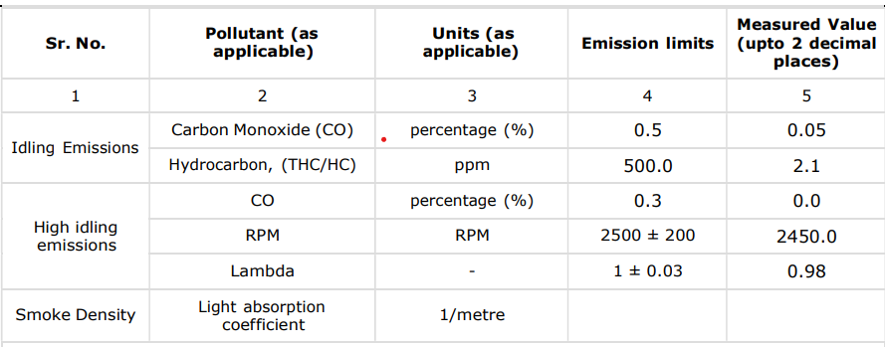

The current PUC (Power Usage Control) system lacks built-in features for real-time monitoring and analysis, which poses a limitation in several ways:

1. *Efficiency*: Without real-time monitoring capabilities, it's difficult to gauge the system's efficiency accurately. Users are unable to track power consumption patterns or identify areas where energy is being wasted, leading to suboptimal usage and increased costs.

2. *Portability*: The absence of built-in monitoring features hampers the portability of the system. Users may need to rely on external monitoring devices or software, which can be cumbersome and may not always be feasible, especially in remote or mobile environments.

3. *Cost-effectiveness*: Integrating real-time monitoring features into the PUC system could potentially increase initial costs. However, in the long run, the benefits of optimized energy usage and reduced downtime could outweigh the initial investment, making the system more cost-effective overall.

4. *Time efficiency*: Without real-time data on power consumption and performance metrics, troubleshooting issues and optimizing system settings can be time-consuming. Users may need to conduct manual inspections or wait for periodic reports, leading to delays in addressing problems and maximizing efficiency.

By incorporating built-in features for real-time monitoring and analysis, such as sensors and data logging capabilities, the PUC system can overcome these limitations. Users would gain access to timely insights into power usage, runtime values, and system performance, enabling them to make informed decisions, improve efficiency, and reduce operational costs. Additionally, the enhanced portability and ease of use would make the system more versatile and adaptable to various applications and environments.

## 3. Problem Statement

### **3.1 Project Requirement Specification-**

1. ESP32 –

The ESP32 is a flexible microcontroller that comes with built-in Bluetooth and Wi-Fi, making it a great option for Internet of Things-based vehicle emission control and monitoring. Its low-power modes add to its longer operational life, which is important for in-vehicle applications, and its dual-core processor guarantees efficient data processing. The ESP32's set of GPIO pins, which includes analog inputs, makes it easy to interface with different sensors for environmental monitoring.

The integrity of data transfer is improved by security features like cryptographic accelerators and secure boot. The ESP32's dual-core architecture guarantees efficient multitasking, and its capability for Over-the-Air upgrades enables remote firmware changes. The microcontroller in question is very compatible with IoT-based automotive emission control systems due to its compact form factor, abundant documentation, and thriving community.

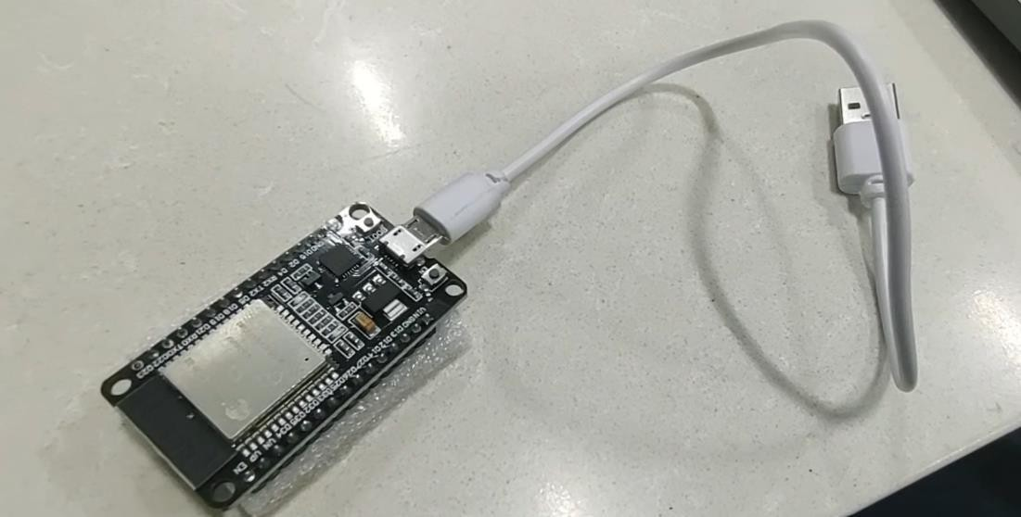

Figure 3.1.1 ESP 32 Dev Board with USB micro B cable

2. MQ135 –

The MQ-135 gas sensor is a small, reasonably priced instrument that can identify a wide range of gases, which makes it useful for air quality monitoring applications. This sensor is very good at picking up on a variety of volatile organic chemicals and gases like carbon dioxide, ammonia, and benzene. The MQ-135 functions based on the idea that resistance varies according to the target gas concentration. Because of its analog output, microcontrollers can be easily interfaced with it. Because of its adaptability, sensitivity, and simplicity of integration, this sensor is widely used for tasks including pollution detection and indoor air quality monitoring in settings where accurate gas sensing is essential.

Precise measurement is made possible by its analog output, which produces a voltage according to the measured gas's concentration. The MQ-135 has a quick reaction time and performs well in a variety of environmental settings. In this project, the ground pin was linked to the esp32's ground, the voltage pin to the vcc, and the analog pin to pin D35.

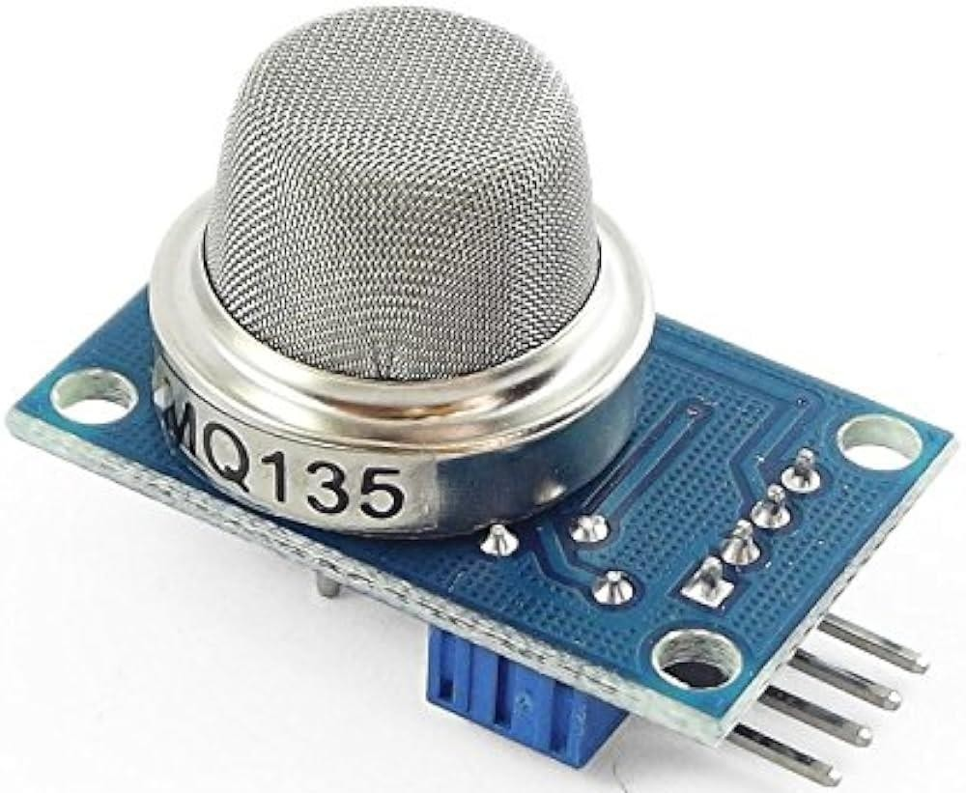

Figure 3.1.2 MQ135

1. MQ2 –

The multifunctional MQ-2 gas sensor module is intended to identify different flammable gases and smoke in the atmosphere. It is appropriate for uses like gas leak detection and air quality monitoring due to its sensitivity to gases including methane, propane, carbon monoxide, and smoke. To provide precise measurements, the sensor outputs an analog voltage according to the concentration of the detected gas. Changes in gas concentrations can be swiftly detected by the MQ-2 thanks to its high sensitivity and quick response time. Its cost-effectiveness, small size, and simplicity of integration with microcontrollers make it a popular choice for Internet of Things applications, such as those that monitor and regulate automobile emissions. In this project, the ground pin was linked to the esp32's ground, the voltage pin to the vcc, and the analog pin to pin D32.

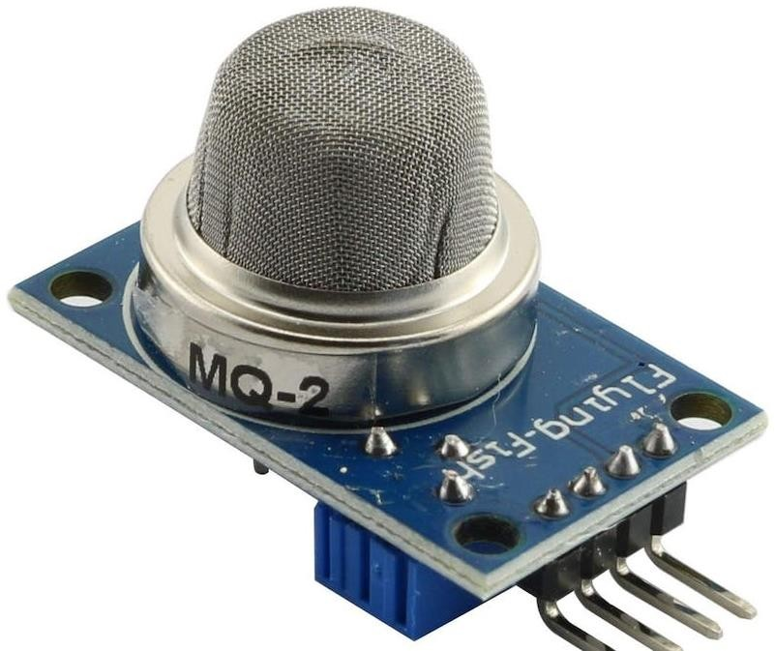

Figure 3.1.3 MQ2

1. MQ7 –

The MQ-7 gas sensor module is well-known for its capacity to identify natural gas and carbon monoxide (CO) in the atmosphere. Due to its high sensitivity to various gases, this little sensor offers a dependable way to check the quality of the air indoors and find possible gas leaks. The MQ-7 enables accurate measurements with an analog output that changes proportionately to the CO or natural gas content. It works well for real-time monitoring applications due to its quick reaction time and great sensitivity. The sensor may be easily integrated into Internet of Things (IoT) systems, especially those that are intended to monitor and regulate automobile emissions, because it is compatible with microcontrollers. The MQ-7 is widely used in a variety of environmental sensing applications because of its low cost, precision, and simplicity of use. In this project, the ground pin was linked to the esp32 ground, the voltage pin to the Vcc, and the analog pin to pin D34.

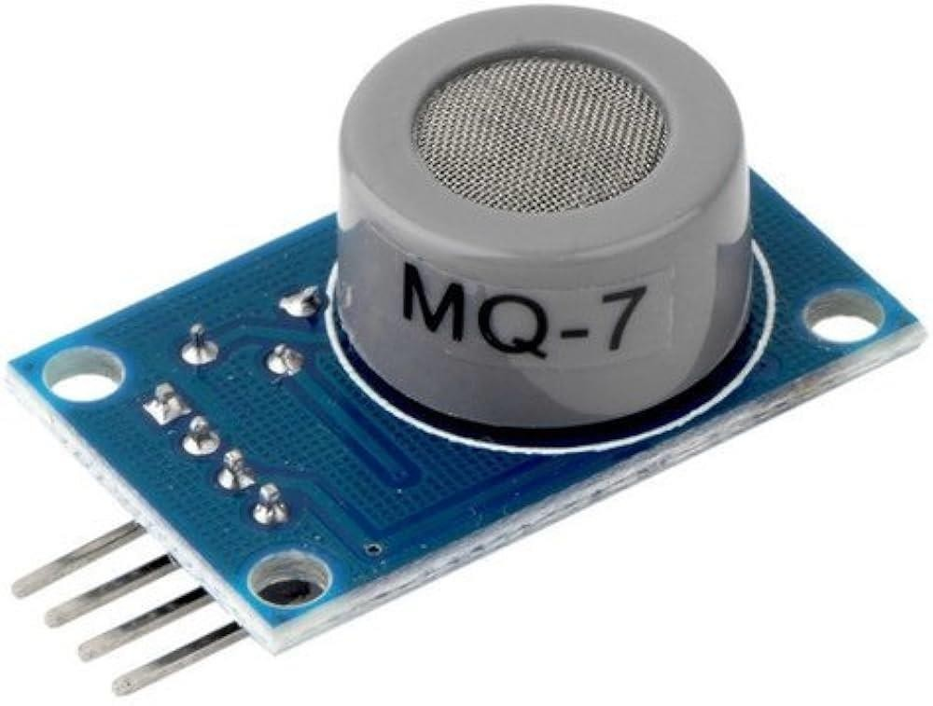

Figure 3.1.4 MQ7

1. Breadboard & jumper wires –

An adaptable solderless prototype board for building and evaluating electronic circuits is called a breadboard. It usually consists of an interlocking grid of metal clips that make it simple to insert and connect components without soldering. Breadboards are versatile tools for experimentation and circuit design since they are available in a range of sizes and configurations. To create flexible connections between various spots on the board, jumper wires are a necessary accessory for breadboards. These cables, which frequently have male-to-male or female-to-male connectors, allow for the rapid and transient linking of components while maintaining an orderly and tidy arrangement. For electronics hobbyists, engineers, and students working on developing and testing circuit prototypes without the permanence of soldered connections, the breadboard and jumper wires are essential tools.

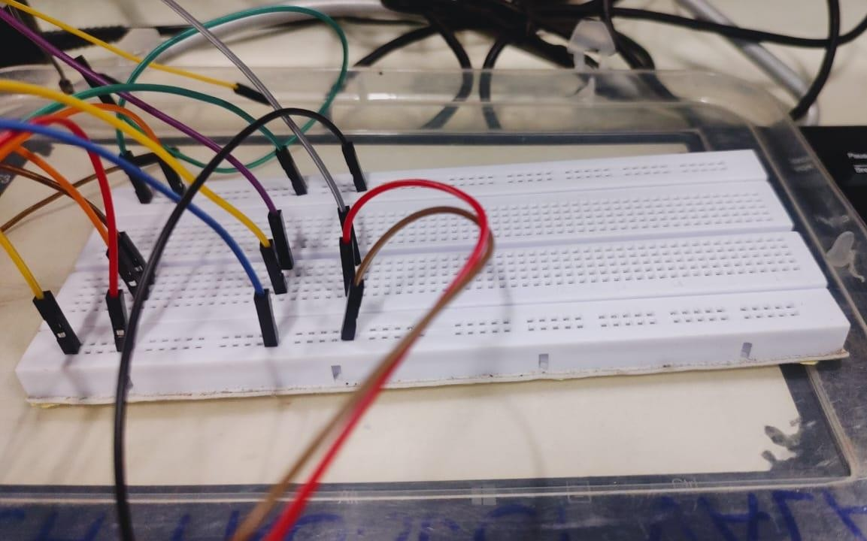

Figure 3.1.5 Breadboard and jumper wires

## 4. Proposed System

### **4.1 Proposed System Architecture**

A portable instrument for determining the amount of vehicle smoke in parts per million (ppm) is depicted in the diagram you submitted. There are four sensors on the device: a smoke unit sensor, MQ2, MQ7, and MQ135 which measures the smoke and gas emitted by the vehicles. A microcontroller receives the sensor data and processes it before displaying the ppm value on a touchscreen display. Gas sensors, a microprocessor, and data processing components are all integrated into the system architecture for a gas monitoring project. Gas concentrations are detected and measured using gas sensors, such as those for hydrocarbons (HC), carbon dioxide (CO2), and carbon monoxide (CO). The raw data from these sensors is supplied into a microcontroller, which handles signal conditioning and data collection.

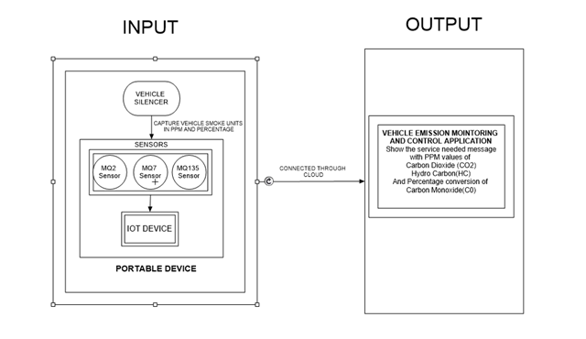

Figure 4.1 System Architecture

In figure 4.1, it contains following components:

* Sensor for vehicle smoke unit: This sensor finds smoke in a moving vehicle. The MQ2, MQ7, and MQ135 sensors are utilized for determining the levels of various gases in the atmosphere.

Were,

MQ2 – For calculating smoke and combustible MQ7 – Detects Carbon Monoxide

MQ 135 – Senses ammonia, sulfur dioxide, carbon monoxide.

* Microcontroller: The microcontroller determines the vehicle smoke percentage (ppm) by processing sensor data.
* Device: The ppm value of the car smoke is shown on the touchscreen display.
* Wi-Fi: The gadget can send the ppm value to a distant application thanks to the Wi-Fi module. In places like parking lots and roads where there is a lot of vehicle activity, the portable gadget can be used to test the quality of the air. In garages and other enclosed areas, it can also be used to detect car smoke.

**4.2 Proposed Methodology**

Algorithm for converting analog input into digital Output

* + Define the analog pins that are attached to the gas sensor s(mq135, mq7, and mq2).
  + Read the MQ-135 sensor’s analog value and save it in the variable mq135Value
  + Read the MQ-7 sensor’s analog value and save it in the variable mq7Value.
  + Read the MQ-2 sensor’s analog value and put it in the variable mq2Value
  + Depending on the sensor specifications and calibration data, you can optionally execute calibration or further data processing on these raw analog values to convert them into useful gas concentration readings
  + Print or use the values as needed (for example, printing to the serial monitor, sending data to a display and sending across a network.

Table 4.2 MQ Sensors details

|  |  |
| --- | --- |
| Sensors Name | Detect |
| MQ2 | Hydrocarbon |
| MQ7 | Hydro monoxide |
| MQ135 | Carbon Dioxide |

*Converting Detecting sensors smoke and steps for converting them into ppm values*

1. **Converting monoxide analog reads to ppm value:**

*float calibrationFactor = x;*

*float voltage = rawValue * (5.0 / 1023.0);*

*float concentration = calibrationFactor * voltage (Equation 1)*

The equation 1 presented converts a raw reading from mq7 sensor `rawValue` into a measurable concentration `concentration` using a calibration factor ‘calibrationFactor`. The raw sensor reading is first scaled according to the voltage range of the system to provide a corresponding voltage value ({voltage}). The concentration measurement is then obtained by multiplying this voltage value by the calibration factor. The accuracy of the sensor's reaction to actual concentrations is guaranteed by this calibration procedure. The equation offers a simple way to derive meaningful concentration values from raw sensor data by taking into account both the calibration factor and the sensor's output. This makes accurate monitoring and analysis possible in a variety of applications.

Steps for converting Carbon Monoxide analog reads to ppm value

1. `voltage` is calculated by scaling the `rawValue` to a voltage value. Since the ADC maps the input voltage range (usually 0-5V) to a range of integer values (0-1023), you're essentially converting the integer ADC reading back to a voltage value. The formula `rawValue * (5.0 / 1023.0)` does this conversion.

2. `calibrationFactor` is a constant specific to your sensor or system. It's used to calibrate the sensor response to match the actual concentration it's measuring.

1. **Converting Carbon dioxide analog read to ppm value:**

*float calibrationFactor = y;*

*float voltage = rawValue * (5.0 / 1023.0);*

*float concentration = calibrationFactor * voltage (Equation 2)*

Equation 2 describes C02 concentration, uses a calibration factor unique to the MQ135 gas sensor to convert a raw sensor reading into a concentration value in parts per million (PPM). Prior to being scaled from the ADC's range to the real voltage range, the raw sensor reading ‘rawValue’ is transformed into a corresponding voltage value ‘voltage’. In order to modify the sensor's response to correspond with actual conditions, the voltage value is subsequently multiplied by a calibration factor. The precision of the concentration measurement in parts per million (PPM) is achieved by multiplying the calibrated voltage value by the calibration factor. This is the estimated concentration of the target gas that the MQ135 sensor successfully identified.

Steps for converting Carbon dioxide analog read to ppm value

1. Multiply the raw sensor reading rawValue by the ratio of the maximum voltage range (5.0V) to the maximum ADC value (1023) and convert it into a voltage value.
2. Multiply the voltage value by the calibration factor to get the concentration in parts per million (PPM).
3. To guarantee correct concentration readings, make sure to swap out the placeholder calibration values with precise ones acquired during calibration studies.
4. **Converting Hydrocarbon analog read to ppm value:**

*float calibrationFactor = z;*

*float voltage = rawValue * (5.0 / 1023.0);*

*float concentration = calibrationFactor * voltage (Equation 3)*

Equation 3 Describe, Using a calibration factor unique to the MQ2 gas sensor, the function transforms a raw sensor signal into a concentration measurement in parts per million (PPM). The function estimates the target gas concentration by scaling the raw sensor data to a voltage value and multiplying it by the calibration factor. To guarantee the dependability and precision of concentration measurements, users should swap out the placeholder calibration values with precise ones discovered during calibration studies.

Steps for converting Hydrocarbon to ppm value

1. Multiply the raw sensor reading rawValue by the ratio of the maximum voltage range (5.0V) to the maximum ADC value (1023) to convert the raw sensor reading to a voltage value.
2. Multiply the voltage value (voltage) by the calibration factor to get the concentration in parts per million (PPM).
3. To guarantee correct concentration readings, make sure to swap out the placeholder calibration values with precise ones acquired during calibration studies.
4. **Details of Hardware &Software requirements**
   1. **Hardware Requirements**
5. ESP32 Development Kit Wi-Fi Module: With integrated Wi-Fi and Bluetooth connection, the ESP32 is a potent microcontroller development board that can be used for a variety of Internet of Things (IoT) applications. Rapid prototyping and deployment of IoT solutions are made possible by the ESP32's vast ecosystem of development tools and libraries, which makes it a popular choice for makers, amateurs, and professional developers alike.
6. Breadboard: An adaptable tool for prototyping in electronics, a breadboard allows circuits to be built and tested without the need for soldering.
7. MQ Series Sensors: Gas sensors that are frequently used to detect different gases in the environment are called MQ sensors. They enable the detection of gases by relying on the alteration in conductivity of metal oxide semiconductors upon exposure to a target gas.
8. Jumper Wires: Jumper wires are straightforward electrical cables with connectors on either end that are frequently used to create impromptu connections between different electronic devices or components on a breadboard.
9. Power Supply (5V) and USB type A cable: An electrical load is supplied with electrical energy by a power supply. Usually, it transforms wall outlet AC electricity into DC power that is appropriate for electrical gadgets. A USB cable is a widely used interface cable that may be used to link peripherals and electrical devices like computers and smartphones. When linked to a.n appropriate power source, it allows for data transfer and can supply power to devices.
   1. **Software Requirements**
10. Arduino IDE latest 2.3.2 version: Version 2.3.2 of the Arduino IDE, the most recent version, brings enhanced performance, stability, and user interface. It contains bug fixes and optimizations to improve Arduino users' overall development process, guaranteeing a more dependable and seamless programming experience. It seeks to ensure a seamless workflow for makers and developers by offering a more streamlined and dependable environment for uploading code to Arduino boards and programming them. Additionally, it can include updates or improvements to speed up the Arduino project development process.
11. Thing Speak Cloud: With the help of the Internet of Things platform ThingSpeak, users may gather, examine, and display data from sensors or other devices in real time. It gives users an intuitive interface for data storage and retrieval, allowing them to develop Internet of Things apps and remotely monitor their devices. With the help of its cloud-based architecture, users may store and retrieve data streams, as well as remotely monitor and operate linked devices. Additionally, ThingSpeak provides MATLAB integration for sophisticated data display and analysis.
12. Mobile Application: Users can easily interact with and operate devices linked to the ESP32 microcontroller board through the project's mobile application. With Wi-Fi or Bluetooth connectivity, users may remotely monitor sensor data, change settings, and get notifications. The mobile app improves the usability and accessibility of the IoT system with features that are particular to the project's functionality and user-friendly interfaces.

## 6. System Design Details

### **Use Case Diagram**

The use case is the overall description diagram of the scenario of the project. It depicts the methodology applied in the system analysis to identify and organize the system of our vehicle emission monitoring and control using IOT. The Vehicle Emission Monitoring System with Internet of Things (IoT) technology offers a real-time monitoring and analysis system that addresses environmental concerns associated with vehicle emissions. The major actors of this project are vehicle and end-user which performs the operations like sensor and device idle state, fetch and show the ppm values.

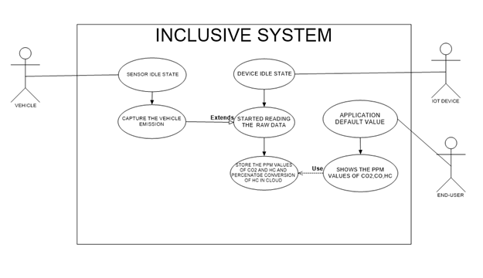

Figure 6.1 Use Case Diagram

The system's principal parts are:

* Sensors: The sensors identify additional gases and smoke in the exhaust of the car. MQ2, MQ7, and MQ135 are common sensors found in car smoke detection systems.
* Microcontroller: The system's brain is the microcontroller. It gathers information from the sensors, analyzes it, and uses that information to make decisions.
* Display: The display provides the user with the outcomes of the smoke detection procedure.
* Interface for communication: The interface for communication enables the system to speak with other gadgets, like a computer or smartphone.

Here's how the system operates:

The sensors identify additional gases and smoke in the exhaust of the car. The microcontroller receives data from the sensors. The concentration of smoke and other gases is computed by the microcontroller after processing the data. The microcontroller checks to see if the smoke content has risen above a predetermined level. The microcontroller triggers the alarm if the amount of smoke exceeds the predetermined threshold. The user is made aware of the existence of smoke in the car's exhaust by the alarm. Additionally, over time, the system can be used to gather information about the vehicle's emissions. This information can be used to track the success of pollution reduction measures and identify cars that areproducing excessive amounts of smoke.

### **Object Diagram**

In figure 5.2, this object diagram shows a car's smoke monitoring system, which is made up of different sensors and gadgets that are connected to the car. It highlights the relationships between the many parts and how they work together to collect, analyze, and display data.

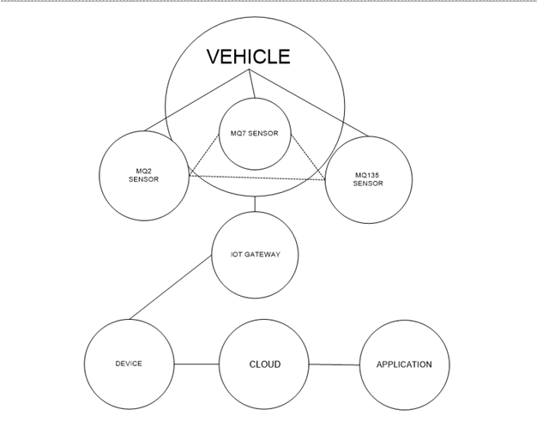

Figure 6.2 Object Diagram

* Vehicle: This stands for the host system, which is the platform on which monitoring system is set up.
* MQ7 Sensor: This sensor is designed to identify emissions of carbon monoxide (CO), a major contaminant found in vehicle exhaust.
* MQ2 Sensor: This sensor detects the existence of gases that might catch fire, such as hydrogen (H2), hydrocarbon (HC).
* The MQ135 sensor detects a number of chemicals, including carbon dioxide (CO2). It analyzes the general quality of the air.
* IoT Gateway: This gadget serves as a link between external network and sensors within the car. It gathers, processes, and sends sensor data to a cloud-based server for additional analysis and display.
* Device: This is a representation of the user interface or program that allows the owner of the car to view and manage sensor data. It could be a specific dashboard, a web portal, or a mobile app.

The graphic illustrates how these elements interact with one another:

Gas concentrations are continuously measured by the car's sensors, which also transmit data to the IoT gateway. The sensor data is received by the IoT gateway, which classifies and formats it into an appropriate format. The device receives the processed data and displays it in an easy-to-use format. The gadget gives the user access to monitor and analyze sensor data, giving them information about the vehicle's emissions and the general quality of the air. By utilizing IoT technology to continuously monitor, analyze, and report car emissions, this thorough process promotes environmental sustainability and well-informed decision- making.

### **Sequence Diagram**

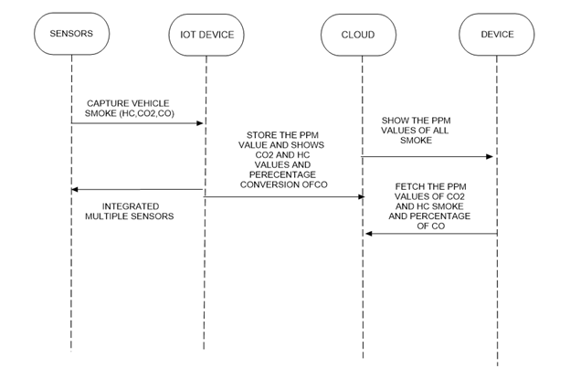

Figure 6.3 Sequence Diagram

The system for measuring and identifying car smoke is simplified in the figure 5.3. It consists of multiple parts that cooperate to monitor and sound an alert for elevated smoke levels. The diagram shows a useful method for detecting and monitoring vehicle smoke emissions, which promotes environmental safety and well-informed decision-making.

Multiple Sensors: The MQ2, MQ7, and MQ135 major sensors are used by the system. Certain gases that are frequently found in car smoke are detected by these sensors:

* MQ2: Finds gases that can catch fire, such as hydrogen, propane, and methane.
* MQ7: Monitors the concentrations of carbon monoxide (CO), a major part of automotive exhaust.
* MQ135: Evaluates a range of gases that are involved in air pollution, including carbon dioxide (CO2). The system's primary processing unit is made up of the ESP32 module and breadboard. A breadboard connects the sensors and microprocessor to provide a platform for prototyping. An integrated

microcontroller known as the ESP32 Module collects, processes, and exchanges data with other devices.

* Capture Car Smoke: The breadboard-connected smoke unit sensor senses the presence of car smoke.
* Obtain PPM Value: After receiving information from the sensors, the microcontroller determines each gas's concentration in parts per million (ppm).
* Show All Values: A display device receives the ppm values from the microcontroller and displays the current smoke component levels.
* USB or Wi-Fi Connection: The ESP32 module allows data transmission to other devices over USB or Wi-Fi, facilitating integration with distant systems or real-time monitoring.

### **State Diagram**

A straightforward interaction between a car and a gadget that measures and displays the car's smoke emissions is depicted in the figure 5.4. State diagrams enable you to describe the behavior of objects during their entire life span. In addition, the different states and state changes as well as events causing transitions can be described.

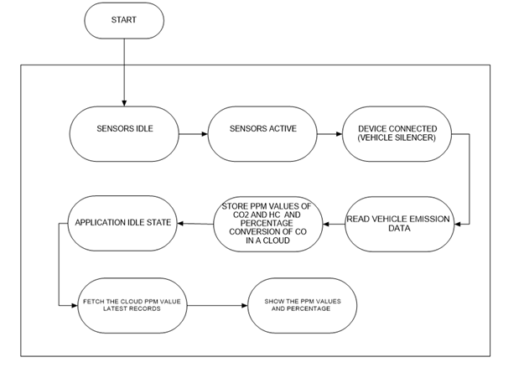

Figure 6.4 State Diagram

Here is the order in which things happened:

To capture smoke, the Device notifies the Vehicle via message. The car collects smoke from the exhaust pipe and transmits the device's ppm value to it. The ppm value is shown on the device's screen. Additionally, a Note labeled "Integrated multiple sensors" is displayed in the diagram. This suggests that the apparatus might have several sensors, including MQ2, MQ7, and MQ135 to gauge the quantity of various gases in car smoke.

Step 1: To catch smoke, the device communicates with the vehicle. A number of communication protocols, including Bluetooth, Wi-Fi, and CAN bus, can be used to send this message.

Step 2: The car collects smoke from the exhaust pipe and transmits the device's ppm measurement. The amount of smoke particles in the air is measured in parts per million, or ppm. The vehicle can use one of its current sensors, such the oxygen or exhaust gas temperature sensors, or it could have a special sensor for monitoring smoke.

Step 3: The ppm value is shown on the screen by the device. The ppm number may also be uploaded to a cloud-based service or stored on the device for analysis at a later time.

## 7. Feasibility Study

### **Introduction to Feasibility Study**

A feasibility study is a thorough analysis that determines the viability, practicality, and likelihood of success of a proposed project. It looks at the project's viability from a number of angles, including its economic, technical, behavioral, time, and resource elements. A feasibility study's objectives are to ascertain whether the project is worthwhile and to pinpoint any possible dangers or difficulties that would need to be resolved.

Usually, the research entails a thorough analysis of a number of factors, such as operational, legal, technological, financial, and scheduling issues. Regarding the technical element, the study evaluates the availability and viability of the technology needed for the project. It assesses the financial sustainability from an economic standpoint by projecting expenses, possible income, and return on investment. Legal factors include assessing any legal restrictions and regulatory compliance. Operational feasibility examines how feasible it would be to carry out and manage the suggested project. The scheduling component determines how long a project will take to finish. By giving stakeholders a comprehensive grasp of the project's possible dangers, difficulties, and opportunities, the feasibility study hopes to empower them to make well-informed decisions about whether to move on with the planned project as is, make changes to it, or scrap it entirely.

A feasibility study in the context of IoT-based vehicle pollution monitoring and control would take the following aspects into account:

* Economic viability: Is there a chance the project will be financed and yield a profit?
* Technical viability: Can the project be supported by the current state of the underlying technology?
* Behavioral viability: Will interested parties embrace the new technology and alter their conduct?
* Time feasibility: Is it possible to do the project in the allotted amount of time?
* Resource viability: Do the resources needed to finish the project exist?

### **Economic Feasibility**

The cost of the technology, the possible savings from lower emissions, and the potential revenue from the sale of data or services are some of the criteria that determine whether vehicle emission monitoring and control using IoT is economically feasible. Depending on the particular sensors and software utilized, the technology's price will change. However, as the technology advances and is embraced by more people, its cost should fall down.

Estimating the costs of the initial investment, continuing operating expenditures, and prospective income are all included in this. The assessment of economic feasibility takes into account various elements, including revenue estimates, pricing methods, and market demand. It assesses the project's financial effects on the larger business environment as well. The financial attractiveness of the project is typically evaluated using financial measures like payback period, internal rate of return (IRR), and net present value (NPV). Sensitivity analysis may also be performed to determine the potential effects of changing important factors on the project's economic viability. The economic feasibility study's objective is to give stakeholders a comprehensive grasp of the project's financial implications and risks so that decision-makers may assess the project's economic viability and suitability.

Depending on how well the technology reduces emissions, there may be savings from lower emissions. On the other hand, research indicates that emissions can be greatly decreased via IoT-based car emission monitoring and control systems. The demand for the services or data in question will determine how much money may be made from their sale. On the other hand, real-time data collection and transmission of vehicle emissions data is becoming increasingly necessary, thanks to IoT-based systems.

In general, the economic viability of utilizing IoT for car pollution monitoring and management is encouraging. Data on car emissions is becoming more and more in demand, and the technology has the ability to save costs and cut emissions. Furthermore, the data produced can be applied to focused policy interventions, such emissions-based taxation or congestion pricing, which promote an environmentally responsible and sustainable transportation system. Moreover, predictive maintenance is made possible by the integration of IoT with emission control systems, which lowers overall operating costsfor car owners and promotes the development of a more effective and financially viable transportation infrastructure.

In general, the integration of IoT technology in vehicle emission monitoring and control not only mitigates environmental issues but also presents enduring financial advantages by means of increased vehicle performance, optimum resource allocation, and heightened regulatory compliance.

### **Technical Feasibility**

A technical feasibility study is an organized analysis carried out to see whether a suggested project or technology can be implemented in a practical and viable manner. The technical elements and competencies necessary for the project's effective development and implementation are the main focus of this study. In order to ascertain if the required technology is now accessible or needs to be developed, it starts by looking at the state of technology. The feasibility of the suggested technology in relation to current infrastructure and systems is also taken into account in the analysis.The technological viability of utilizing IoT for car emission monitoring and control is contingent uponthe advancement of technology and the accessibility of requisite infrastructure. IoT-based car pollution monitoring and control technology is getting along rather well. To track and manage vehicle emissions, a variety of commercially accessible sensors and software options are available.

This data can subsequently be processed by sophisticated analytics and machine learning algorithms, allowing the identification of emission patterns and abnormalities. Remote monitoring and control features make it possible to respond quickly to abnormalities, which helps with timely maintenance and lessens the impact on the environment. Furthermore, IoT technologies' scalability guarantees their application to a variety of infrastructure and vehicle fleets. The growing number of connected cars has created a technically sound basis for IoT-based comprehensive pollution monitoring and management, opening the door to a transportation ecosystem that is both more technologically sophisticated and environmentally friendly.

An examination of the hardware and software requirements, potential technical difficulties, and the availability of qualified staff are essential elements of a technical feasibility study. It determines any risks related to technology adoption and evaluates whether the project can be carried out within the specified technological limitations. The study also examines other technical options and weighs the benefits and drawbacks of each. It attempts to give decision-makers information about the project's technical viability so they can determine whether the suggested solution fits the organization's goals and capabilities. The technical feasibility study's conclusion helps stakeholders make well-informed decisions regarding the project's advancement by confirming that it is both technically feasible and theoretically feasible. Additionally, there is a growing availability of the infrastructure required for IoT-based car emission monitoring and control. Both the network of IoT-enabled devices and the amount of data on car emissions are expanding. IoT-based vehicle pollution monitoring and control has a high technical viability overall. Technology is advanced, and the infrastructure needed to support it is getting easier to obtain.

### **Behavioral Feasibility**

A behavioral feasibility assessment is a comprehensive analysis of the organizational and human aspects that could affect how well a project or system is implemented. The goal of this study is to comprehend potential reactions to the suggested modifications from both internal and external stakeholders inside a business. It evaluates the interpersonal relationships, mindsets, and cultural nuances that might affect the project's outcome. An examination of the company culture as a whole, possible resistance, and employee preparedness for change are important components of a behavioral feasibility study.

The desire of stakeholders to embrace the new technology and modify their behavior is what determines if behaviorally-based vehicle emission monitoring and control via IoT is feasible. Policymakers, fleet managers, car owners, and members of the public are examples of stakeholders. Owners of vehicles might be worried about the technology's potential costs and privacy effects. Fleet managers could be worried about the complexity and expense of putting the technology into practice. The technology's potential legal and regulatory ramifications may worry policymakers. Concerns regarding the technology's fairness and efficacy can exist among the general public.

The goal of the study is to pinpoint potential problems with organizational dynamics and human behavior, such as reluctance to adopt new procedures, a lack of training, or cultural barriers. To obtain information from staff members, managers, and other pertinent stakeholders, surveys, interviews, and focus groups are frequently held. In the end, the knowledge gathered from the behavioral feasibility study helps to provide a more comprehensive evaluation of the project's viability and

It's critical to inform stakeholders about the advantages of the technology and to apply it in a transparent, equitable, and economical manner in order to allay these worries. IoT-based Vehicle pollution monitoring and control has a moderate overall behavioral viability. There may be certain difficulties, however outreach and education can help with these difficulties.

To gain support, it is essential to run public education campaigns and communicate clearly about the advantages of emission monitoring, such as better air quality and fewer health hazards. Potential resistance can also be lessened by addressing privacy issues and making sure data usage policies are transparent. The key to achieving behavioral feasibility is fostering an environment-aware and responsible culture that will motivate people and businesses to use IoT-based sustainable car emission control systems.

### **Time Feasibility**

Depending on resource availability and project complexity, IoT-based vehicle emission monitoring and control may or may not be feasible in a timely manner. In a few months, a small-scale trial project may be finished. A significant deployment project can take a number of years. The project's timeliness will be impacted by resource availability as well. Should the required resources not be accessible, the project will have to be postponed or reduced in scope.

One of the most important aspects of project appraisal is time feasibility, which determines whether or not a project can be finished in the allotted amount of time. Analyzing the project's schedule, deadlines, and total time needed for creation, implementation, and completion is the focus of this feasibility study component. It takes into account things like the intricacy of the project, the resources at hand, and how quickly the project's results must be delivered. Establishing milestones, predicting the amount of time needed for each stage of the project life cycle, and developing realistic project schedules are all parts of time feasibility.

Decision-makers can learn more about a project's temporal viability and make sure it fits the organization's goals and can be finished in a reasonable amount of time by doing a time feasibility study. It offers a foundation for risk management, resource allocation, and realistic project planning. The study also helps to develop expectations for stakeholders and makes it possible to create a clear schedule for project milestones, which makes it easier to monitor and manage the project. In the end, time feasibility is essential to figuring out if the project can be completed in the allotted amount of time without sacrificing goals or quality. Overall, the time feasibility of vehicle emission monitoring and control using IoT is moderate. It is possible to finish the job in a fair amount of time, but careful preparation and execution are needed.

IoT's real-time capability makes it possible to monitor and react to emission events instantly, which helps with more prompt maintenance and regulatory compliance. The proliferation of linked automobiles and the ongoing development of IoT platforms also hasten the integration process. The timely and feasible implementation of IoT solutions offers an effective means of improving emission monitoring and control capabilities, particularly in light of the pressing need to address environmental concerns associated with vehicle emissions.

### **Resource Feasibility**

Given the accessibility and affordability of the necessary technology, the viability of deploying Vehicle Emission Monitoring and Control through the Internet of Things appears promising in terms of resources. The cost-effectiveness and accessibility of Internet of Things devices, sensors, and communication modules are rising, making it possible to integrate them into a variety of automobiles.

A crucial component of project assessment is time feasibility, which determines if a project can actually be finished in the allotted amount of time. This part of the feasibility study looks at a variety of time-related factors, such as the project's total duration, the timetables for each activity, and the project's ability to fulfill deadlines. Project managers and other stakeholders examine variables such the project's complexity, resource availability, and the urgency of completing the project's results in order to determine whether it can be completed on schedule. A thorough project timeline, milestones, and an estimation of the time needed for each stage of development, implementation, and completion are all part of the study.

The availability of the required resources, such as the following, determines the viability of employing IoT for car emission monitoring and control:

* Sensors: To track car emissions, the project will need a range of sensors. These sensors must be long- lasting, precise, and simple to install and maintain.
* Software: To gather, process, and send data from the sensors, the project will need software. Secure and dependable software is required.
* Network: In order to transfer data from the cars to a central location, the project will need a network. This network requires

## 8. Experimentation and Result

## 8.1 Details of Database/Dataset:

## The spreadsheet that is included provides an extensive record of sensor data that has been carefully timestamped and classified into discrete gas measurements from sensors that are identified as "MQ135," "MQ7," and "MQ2." These sensors give vital information in parts per million (ppm) and percentage units. They are intended to detect carbon dioxide (CO2), carbon monoxide (CO), and hydrocarbons (HC), respectively. This dataset probably plays important roles in safety systems or environmental monitoring, where rapid and accurate gas level detection is essential. An additional layer of functionality is added by including an output column that indicates when a service is required. This column can notify operators or systems of unusual readings that exceed predetermined criteria or suggest possible sensor malfunction. Stakeholders can use machine learning algorithms or advanced analytics with this dataset to forecast trends, get insights, and maximize reactions, resulting in a setting

that is safer and healthier in the end.

Table 8.1 Sensor's calibrated values dataset

## Inserting image...

The spreadsheet that is provided provides four different line charts with the title "Vehicle Smoke Emission," each of which provides a comprehensive visual representation. Every graph provides a time-series summary of emissions, most likely correlated with several car smoke emissions measurements. These charts are noteworthy because they show variations in emissions over time, which probably reflects the dynamic nature of traffic or surrounding circumstances. A noticeable rise in emissions that was noticed on April 4th around noon is especially noteworthy since it appears to indicate an abrupt surge in smoke output during that time. It's important to note, though, that the smoke emissions data points in the fourth graphic seem to be missing, which could hint to a gap due to the categorical data in 4th field. These kinds of visualizations are very useful for tracking trends or abnormalities in air quality and helping stakeholders make decisions about public health, environmental management, and regulatory compliance. In addition to providing deeper insights into the mechanisms influencing these emissions patterns, further data analysis and contextual information could help guide targeted measures aimed at reducing the emissions' negative effects on public health and air quality.

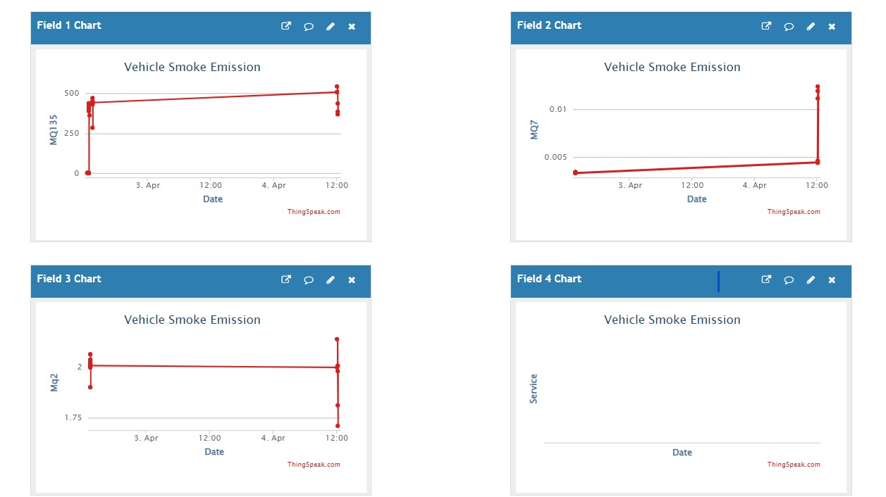

Figure 8.1 Data Visualization of MQ sensor data

## 8.2 Block by block results of complete experimentation

## Step 1: Taking analog/raw values from sensor

## Gas sensors, like the MQ135 for carbon dioxide (CO2), MQ7 for carbon monoxide (CO), and MQ2 for hydrocarbons (HC), usually provide analog signals as the output data, which indicate the concentration levels of the individual gases. These analog outputs are vital markers of the concentrations of ambient gases and are essential components of safety and environmental monitoring systems. But it's important to recognize that unprocessed analog data from these sensors could have some drawbacks, mainly because of uncalibrated and intrinsically variable sensor performance.

## These restrictions highlight how crucial calibration is for gas sensor applications. In order to establish trustworthy correlations between sensor outputs and real gas concentrations, calibration entails comparing sensor data to established reference standards or carrying out empirical testing. Users can improve measurement accuracy, lessen the effects of inherent variability, and guarantee the correctness of data interpretations by calibrating gas sensors. Inaccurate conclusions, poor choices, and reduced efficacy in safety and environmental monitoring applications can arise from gas sensor calibration errors. Thus, in order to fully utilize gas sensor data and ensure precise and useful insights into gas emissions and air quality, it is crucial to identify and resolve the restrictions related to non-calibrated data.

## 

Figure 8.2.1 Analog/raw values from MQ sensor

## Step 2 : Calibrating data and uploading to cloud

The gas sensors' raw analog outputs are painstakingly fine-tuned and refined through calibration so that they precisely match known gas concentrations. Correlating the sensor outputs with these reference values entails exposing the sensors to controlled gas environments with known concentrations. The raw sensor data is converted into certified data by creating exact calibration curves or equations, guaranteeing a clear and consistent correlation between sensor readings and actual gas concentrations.

The calibrated sensor data is far more useful for safety and environmental monitoring applications when the calibration process is finished. It provides improved precision and dependability, allowing interested parties to base their decisions on reliable measurements of gas concentration. Furthermore, calibrated sensor data can be easily sent to cloud platforms for additional analysis and visualization thanks to the development of IoT (Internet of Things) technology.



Figure 8.2.2 Data Visualization from ThingSpeak cloud

## Step 3: Mobile app to show latest reading and review from existing system user.

A smartphone application provides a handy interface for obtaining and visualizing the calibrated sensor data stored in the ThingSpeak cloud platform, as it relates to the gas sensor data previously stated. By utilizing mobile technology, users can easily keep an eye on gas concentrations in real-time and obtain information about the surrounding environment right from their tablets or smartphones. The mobile application creates a smooth connection with the ThingSpeak cloud, retrieves the sensor data that has been calibrated, and presents it in an intuitive interface.

The application leverages the potential of mobile technology and cloud-based data analytics to enable smooth access to sensor data that has been calibrated. This promotes increased environmental stewardship knowledge and accountability.

|  |  |
| --- | --- |
|  |  |

Figure 8.2.3 Mobile application to read data

One of our users has complimented our project and said how good it is at giving insightful information about the state of the environment. The smartphone app's accessibility and simplicity are especially valued by them, since it enables them to take proactive measures to address environmental concerns and monitor gas concentrations in real-time. Their encouraging comments are proof of our project's effectiveness and applicability in enabling people to make wise decisions and practice environmental stewardship.

## 

Figure 8.2.4 User's review on project

## 8.3 Discussion

## 1. Receiving analog data from sensor:

The main step in the data reception procedure is reading analog values from gas sensors that are attached to the Arduino board. The analogRead() function accomplishes this by retrieving raw sensor data from the designated analog pins that correspond to each sensor (MQ-2, MQ-7, and MQ-35). The electrical signals that the gas sensors produce in response to the presence of target gases in the surrounding air are represented by these analog values.

2. Calibrating analog data:

Selecting the proper calibration factors for each gas sensor (MQ-2, MQ-7, MQ-135) is the first step in the calibration procedure. These variables are unique to each type of sensor and are usually found by trial and error and comparison with established reference values or calibration gases. For instance, the MQ2convertToPPM() method calibrates raw voltage data from the MQ-2 sensor to PPM concentrations of hydrocarbons using a factor of 1.15. In a similar vein, calibration parameters specific to the target gases and sensing characteristics of the MQ-7 and MQ-135 sensors are developed.

For sensor values to remain reliable and accurate over time, regular calibration is essential. The performance of sensors can be affected by changes in the environment, aging of the sensor, and other factors, necessitating periodic changes to the calibration factors. Frequent recalibration and ongoing observation aid in sensor detection.

3. Uploading data to ThingSpeak Cloud:

After conversion, the resulting PPM concentration values are ready for further processing or transmission. In the provided code, these values are printed to the serial monitor for real-time monitoring and debugging purposes. Additionally, the sketch utilizes the WiFi and ThingSpeak libraries to transmit the sensor data to the ThingSpeak platform for logging and visualization. The data is formatted according to ThingSpeak's requirements and sent over the internet using the WiFi connection established by the Arduino board.

4. Showing data in app:

Displaying data from the cloud in a mobile app involves retrieving information stored remotely on a cloud platform and presenting it in a user-friendly format within the app interface. In the context of the provided code, data is sent to the ThingSpeak platform for storage and visualization. Once the data is logged on ThingSpeak, it can be accessed via APIs provided by the platform.

## 9. Conclusion

Vehicle emissions play a major role in air pollution, which poses a substantial risk to both human and environmental health. Vehicle emissions may be tracked and managed using IoT-based technologies, which can also help to improve air quality. These systems can gather information on car emissions in run time, allowing for the identification of high-emitting vehicles and the development of focused emission reduction plans. The effectiveness of emission control measures can be monitored using IOT-based systems, which can also give information for the creation of regulations. IoT-based vehicle emission monitoring and control systems can be expanded further and improved in a variety of areas. To further cut emissions and enhance air quality, these technologies might relate to other modes of transportation, such as public transit and traffic management systems. These systems could also be employed to create fresh and cutting-edge pollution control technologies. Systems for monitoring and regulating vehicle emissions that are IoT-based have the potential to significantly aid the effort to reduce air pollution.

Air pollution is largely caused by vehicle emissions, which endanger both the environment and human health. Heart disease, lung conditions, and even early death are among the negative consequences of air pollution. IoT-based car emission monitoring and control systems have become a viable approach to address this urgent problem.

IoT-enabled solutions provide a thorough, real-time method of managing and tracking vehicle emissions. These systems gather information on several pollutants, including hydrocarbons and carbon monoxide and carbon dioxide, using a network of sensors and communication devices mounted in cars. After that, the gathered data is sent to a central cloud platform for display and analysis. IoT-based emission monitoring systems provide insights that allow for numerous practical ways to lower air pollution.

* Classification of High-Emitting Vehicles: Through the examination of emission data, regulatory bodies are able to discern automobiles that persistently surpass emission regulations. To reduce their emissions, these cars can be the focus of additional care and inspection.
* Targeted Emission Reduction Plans: With the use of comprehensive emission data, policymakers are able to create plans that are specifically designed to reduce emissions from a given class of vehicle, fuel, and driving behavior. This strategy makes sure that the biggest sources of pollution receive the most of the attention when it comes to emission reduction.
* Keeping an eye on the efficacy of emission control measures IoT-based systems can continuously track the impact of emission control measures, such as fuel standards, emissions testing, and traffic

regulations. This real-time feedback allows for adjustments to be made as needed to optimize the effectiveness of these measures.

* Providing Information for Regulatory Policy Development: The information gathered from IoT systems' emissions can be very helpful in developing and improving emission standards. Policymakers can use this information to establish reasonable and attainable emission regulations for various car classes and fuel types.
* Connecting with Public Transportation and Traffic Management Systems: To encourage greener and more effective modes of transportation, IoT-based emission monitoring systems can be connected with public transit and traffic management systems. By promoting the use of public transit and improving traffic flow, integration can aid in the reduction of overall car emissions.

## References

1. Kumaran, S., Arunachalam, S., Surendar, V., & Sudharsan, T. (2023, February). ”IoT-based Smoke Detection with Air Temperature and Air Humidity; High Accuracy with Machine Learning”. In 2023 Third International Conference on Artificial Intelligence and Smart Energy (ICAIS) (pp. 604-610),IEEE.
2. Kshirsagar, P. R, Manoharan, H, Al-Turjman, F & Maheshwari,K. K. (2020). ”Design and testing of automated smoke monitoring sensors in vehicles”. IEEE Sensors Journal, 22(18), 17497-17504.
3. Riegel, J, H. Neumann, and H-M. Wiedenmann. ”Exhaust gas sensors for automotive emission control.” Solid State Ionics 152 (2002): 783-800.
4. Bharathraj P, Arun Prasad V S, Aswin Kumar M, Shya- malaprasanna A, 2022, ”Vehicle Pollution Monitoring System using IoT, INTERNATIONAL JOURNAL OF ENGINEERING RESEARCH & TECHNOLOGY”, (IJERT) NCICCT – 2022 (Volume 10 – Issue 05).
5. ”Low-Cost CO Detector Integrated with IoT” was authored by Emmanuel Estrada, Miriam Moreno, Karina Mart´ın, A´ lvaro Lemmen Meyer, P.M. Rodrigo, and Sebastia´n Gutie´rrez. It was published by the Universidad Panamericana Aguascalientes in Mexico, IEEE Xplore on August 22, 2023.
6. R. Akhila, B. Amoghavarsha, B. Karthik, Y. Prajwal and Ba- jarangbali, ”Internet of Things based Detection and Analy- sis of Harmful Vehicular Emissions,” 2022 4th International Conference on Smart Systems and Inventive Technology (IC- SSIT), Tirunelveli, India, 2022, pp. 630-636, doi: 10.1109/IC- SSIT53264.2022.9716558..
7. D. Kandris, C. Nakas, D. Vomvas, and G. Koulouras, “Applications 591 of wireless sensor networks: An up-to-date survey,” Appl. Syst. Innov., 592 vol. 3, no. 1, pp. 1–24, Mar. 2020. 593
8. S. Ullo et al., “Application of wireless sensor networks to environmental 594 monitoring for sustainable mobility,” in Proc. IEEE Int. Conf. Environ. 595 Eng. (EE), Mar. 2018, pp. 1–7. 596.
9. S. Kaivonen and E. C.-H. Ngai, “Real-time air pollution monitoring with 597 sensors on city bus,” Digit. Commun. Netw., vol. 6, no. 1, pp. 23–30, 598 Feb. 2020. 599.
10. L. Andrea, R. Abirami, M. Diviya, and J. S. Nancy, “Framework for fire 605 detection and mitigation using IoT,” Int. J. Pure Appl. Math., vol. 118, 606 no. 18, pp. 1801–1811, 2018. 607
11. Q. Wu et al., “Intelligent smoke alarm system with wireless sensor 608 network using ZigBee,” Wireless Commun. Mobile Comput., vol. 2018, 609 no. 2, pp. 1–11, 2018. 610.
12. K. Arjun, P. Prithviraj, and A. Ashwitha, “Sensor based application 611 for smart vehicles,” Int. J. Latest Trends Eng. Technol., vol. 8, no. 1, 612 pp. 526–532, Jan. 2017. 613.
13. R. Pi, “An IoI based forest fire detection using raspberry Pi,” Int. J. 614 Recent Technol. Eng., vol. 8, no. 4, pp. 9126–9132, 2019. 615.
14. F. Saeed, A. Paul, A. Rehman, W. Hong, and H. Seo, “IoT-based 618 intelligent modeling of smart home environment for fire prevention and 619 safety,” J. Sens. Actuator Netw., vol. 7, no. 1, p. 11, Mar. 2018. 620.
15. W. Li and W. Zhang, “Sensor selection for improving accuracy of target 621 localisation in wireless visual sensor networks,” IET Wireless Sensor 622 Syst., vol. 2, no. 4, pp. 293–301, Dec. 2012. 623.
16. A. Paul, A. Daniel, A. Ahmed, and S. Rho, “Cooperative cognitive 624 intelligence for Internet of vehicles,” IEEE Sensors J., vol. 11, no. 3, 625 pp. 1–10, 2017. 626.
17. K. D. Singh, P. Rawat, and J.-M. Bonnin, “Cognitive radio for vehicular 627 ad hoc networks (CR- VANETs): Approaches and challenges,” EURASIP 628 J. Wireless Commun. Netw., vol. 2014, no. 1,pp. 1–22, Dec. 2014. 629.
18. M. Younis and K. Akkaya, “Strategies and techniques for node place- 630 ment in wireless sensor
19. M. Maksimovi´c and V. Miloševi´c, “Evaluating the optimal sensor 633 placement for smoke detection,” Yugoslav J. Oper. Res., vol. 26, no. 1, 634 pp. 33–50, 2016. 635.
20. Status of the Vehicular Pollution Control Programme in India, Minist. 636 Environ. For. Govt. India, CPCB, New Delhi, India, 2010, pp. 1–114. 637.
21. R. Salazar-Cabrera, Á. P. de la Cruz, and J. M. M. Molina, “Sustainable 638 transit vehicle tracking service, using intelligent transportation system 639 services and emerging communication technologies: A review,” J. Traffic 640 Transp. Eng., vol. xxx, pp. 1–19, Nov. 2020. 641.
22. J. Wei, C.-H. Chiu, F. Huang, J. Zhang, and C. Cai, “A cost-effective 642 decentralized vehicle remote positioning and tracking system using 643 BeiDou navigation satellite system and mobile network,” EURASIP J. 644 Wireless Commun. Netw., vol. 2019, no. 1, p. 8, Dec. 2019. 645.
23. M. Bernas, B. Płaczek, W. Korski, P. Loska, J. Smyła, and P. Szymała, 646 “A survey and comparison of low-cost sensing technologies for road 647 traffic monitoring,” Sensors, vol. 18, no. 10, pp. 1–27, 2018. 648.
24. B. Misganaw and M. Vidyasagar, “Exploiting ordinal class structure in 653 multiclass classification: Application to ovarian cancer,” IEEE Life Sci. 654 Lett., vol. 1, no. 1, pp. 15–18, Jun. 2015. 655.
25. F. Al-Turjman and J. P. Lemayian, “Intelligence, security, and vehic- 656 ular sensor networks in Internet of Things (IoT)-enabled smart-cities: 657 An overview,” Comput. Electr. Eng., vol. 87, Oct. 2020, Art. no. 106776. 658.
26. S. Ramasubbareddy, S. Ramasamy, K. S. Sahoo, R. L. Kumar, 659 Q.-V. Pham, and N.-N. Dao, “CAVMS: Application-aware cloudlet 660 adaption and VM selection framework for multicloudlet envi- 661 ronment,” IEEE Syst. J., early access, Oct. 26, 2020, doi: 662 10.1109/JSYST.2020.30WW29807.
27. Ramachandra, T V & Kashyap, Shwetmala. (2009). Emissions from India ’ s transport sector : Statewise synthesis. Atmospheric Environment. 43. 5510-5517. 10.1016/j.atmosenv.2009.07.015.

## Copyrights/Patents/Paper and/or Certificate Presented/Published in Conference/Journal

## Proof of Submission

## Paper 1

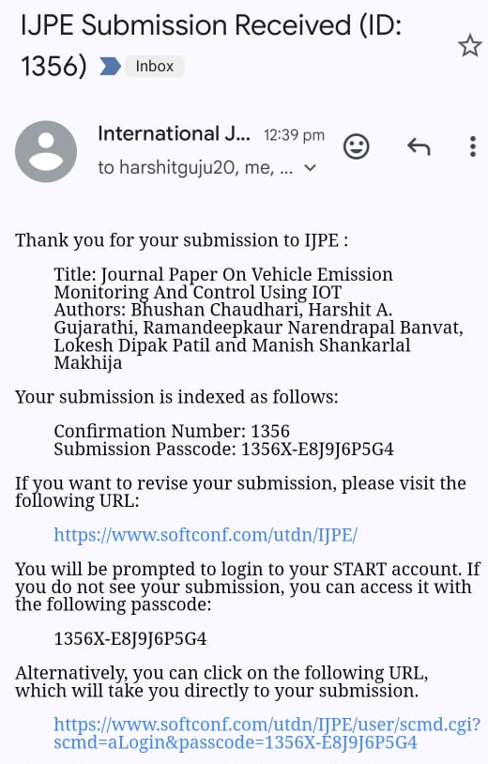

Paper 2

